Introduction

Steganography is the art of science that deals with the process of hiding information within some unrelated contents for establishing a secure communication. Steganography being somewhat similar with cryptology is often confused with cryptology since both of them deal with information security. The only difference between these two is: steganography deals with hiding of information itself, whereas cryptology (study of cryptography and cryptanalysis) deals with encrypting information to make them unreadable.

Image steganography is the main focus of this project where the message or information is hidden or embedded with the image. This project intends to give an overview and implement the image steganography. It also demonstrates the requirement of a good steganography algorithm and demonstrates the implementation of the image steganography in message and information hiding. The basic concept is that the message is to be hidden inside the original image and then to be sent to the receiver, where the receiver retrieves the message by applying de-steganography.

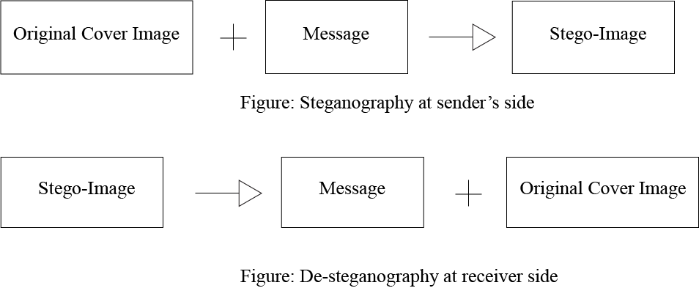

Problem Statement

Generally, steganography includes only embedding the message inside the image, but this project intends to include the encryption and decryption technique along with the embedding process. In general trend, it is found that steganography is not used to deliver the confidential information but this project aims to transfer the confidential information securely using image steganography.

Objective

* To deliver information securely between source and destination.
* To deliver message with the hidden information inside the image using the cryptographic technique of encryption and decryption.
* To provide copyright watermark, information surveillance and delivery of the confidential information.

Literature Review

Image steganography is the technique of hiding the information inside of the images, so that the messages and the information could be kept and transferred secretly. This project is part of steganography technique which uses the objects to hide the information. The proposed project is related to the systems that uses the image to conceal the information.

While on research, it is found that there exist many system which uses image steganography technique. In the paper “Least Significant Bit algorithm for image steganography” [1], the author has used Least Significant Bit algorithm is used for image steganography technique and has proposed to use the 2D matrix of the color (i.e pixel of an image) with RGB model.

In paper [2], author has proposed the use of LSB algorithm and pseudo random encoding technique for hiding the information without destroying the property of the cover image significantly.

To justify the use of LSB algorithm in this project, we have pointed out following points:

1. Simplicity
2. Large embedding capacity
3. Less image distortion

In general trend, image steganography is used only for hiding and retrieving the information which doesn’t include the cryptography techniques for the message security. But this project intends to use a cryptography technique for message encryption and decryption that is concealed inside the image. For the encryption and decryption process, this project implements Advanced Encryption System (AES).

In paper [3], Douglas Selent discusses the detail concept of AES. AES is standard used for encryption of data which uses symmetric-key algorithm. And author has described that implementation of AES was easy with reasonable amount of run time.

In conclusion, this project intends to use cryptographic AES algorithm for message encryption, which is later used to embed the encrypted message into the image using LSB algorithm. While on research, papers were found with implementation of AES algorithm which describes that AES is faster, more secure with larger key size and resistance to implementation attacks and analysis [4]. LSB technique is preferred since it changes last significant bit, so that change in last bit doesn’t make huge difference in the pixel color. And in paper [2], it is stated that using LSB algorithm doesn’t highly destroys the property of the image.

Methodology

1. Requirement Identification

* Study of existing system

By studying the existing system, it is found that steganography tools are used only for hiding the information inside the image. And confidential information are not feasible to embed with the image steganography technique. Existing system is limited only to embed the information in image which does not provide any encryption or decryption technique.

* Requirement Collection

The proposed system is expected to have some of the following requirements but not limited to such as

- A system that can embed the confidential message inside the image

- System with easy user interface

- A system that supports multi-platform environment

- User should be able to embed and retrieve the information using key.

- System should be portable

- The system should be cost effective and affordable

1. Feasibility Study

* Technical

The purposed system is feasible to implement and work with any technological environment. There is no high technical resources demand for the system. One of the reason that system is technically feasible is that it is platform independent. Any non-technical user can work with the system.

* Operational

Project is feasible if only it can successfully embed the message inside the image and the message inside the stego-image should be identical to the original message. The well planned design would ensure the optimal utilization of the computer resources and would help in the improvement of performance. The system should be easy to implement and provide simple and easy interface.

1. Tools

* Analysis and Design tools

There are various presence of designing tools to create figures and diagrams like entity-relationship diagram, flow chart, use case diagram and other desired diagram. In this project SmartDraw 2016 software was used for diagrammatic design of the proposed system.

Use case diagram and flowchart of a proposed system is used to analyze proposed system design. The figures and diagrams help to analyze the application and release the information required to maintain the interaction with the application. It also makes the development process easier and faster.

* Implementation tools

The tool implemented for interface and the programming logic of the system is developed with Java programming language. Front end of the system is developed by using Java Swing package. The front end or the interface is designed with GUI Builder's design features of Java.

Back end of the system is developed with concept of core Java. All the back end functionality is developed and performed with core Java concept.

High level design of proposed system

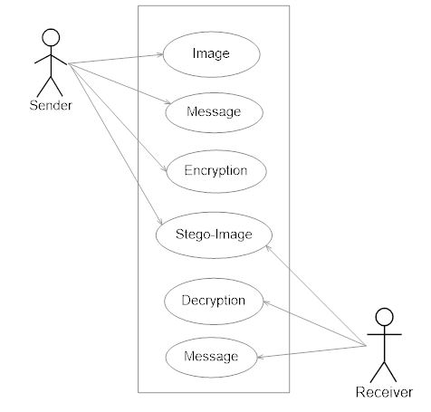

Fig: Use case diagram of proposed system



Fig: System flow chart

Fig: Gantt chart to show the project time planning

The proposed project intends to build a system based on systematic reuse where systems are integrated from existing components. The reusable components can be library files, frameworks, extension or other components that can be reused. Since the project tries to reuse the components and integrate them to develop a system, the appropriate development life cycle would be ‘Reuse oriented development’ or ‘Component based model’. The above Gantt chart shows the projected time planning of a proposed system, in which the phases are scheduled with reuse oriented development model.

Expected Outcome

* The system should perform encryption and decryption of the confidential message with image stenography
* The message inside the stego-image should be identical to the original messages
* The outcome of this project is expected to start a practice of encryption and decryption technique with image stenography.

References

1. Champakamala .B.S, Padmini.K, Radhika .D. K Asst Professors, “Least Significant Bit algorithm for image steganography”, International Journal of Advanced Computer Technology, Volume 3, Number 4.
2. Kshetrimayum Jenita Devi, “A Secure Image Steganography Using LSB Technique and Pseudo Random Encoding Technique”, Department of Computer Science and Engineering National Institute of Technology Rourkel, May 2013.
3. Douglas Selent, “Advanced Encryption Standard”, Rivier Academic Journal, Volume 6, Number 2, Fall 2010.
4. http://www.met.edu/Institutes/ICS/NCNHIT/papers/33.pdf
5. https://cyfor.engineering.nyu.edu/topic/02-lsb-steganography/